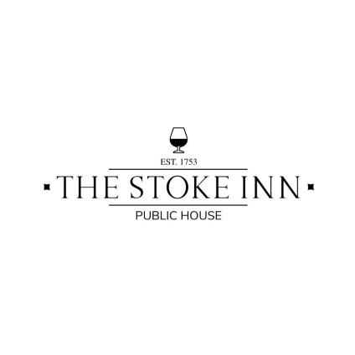

**Monday – Sunday 08:00 – 11:30**

**Breakfast**

**Small Classic £7**  
One sausage, one smoked bacon rasher, fried egg, tomatoes, baked beans, mushrooms, fried potatoes + toasted bread

**Large Classic £9**  
Two sausages, two smoked bacon rashers, fried egg, tomatoes, baked beans, mushrooms, black pudding, fried potatoes + two pieces of toasted bread

**Small Vegetarian (V) £6**  
One vegetarian sausage, fried egg, tomatoes, baked beans, mushrooms, fried potatoes, wilted spinach & toasted bread

**Large Vegetarian (V) £8**  
Two vegetarian sausages, fried egg, tomatoes, baked beans, mushrooms, fried potatoes, wilted spinach & two pieces of toasted bread

**Small Vegan (VE) £5**  
One vegetarian sausage, tomatoes, baked beans, mushrooms, fried potatoes, wilted spinach & toasted bread

**Large Vegan (VE) £7**  
Two vegetarian sausages, tomatoes, baked beans, mushrooms, fried potatoes, wilted spinach &   
two pieces of toasted bread

*Each of the above breakfast meals are served with unlimited tea or instant coffee*

**The Stoke Inn Sarnie £5**  
Sausage, smoked bacon rasher, fried egg, fried potatoes & black pudding in ciabatta bread

**Breakfast Bap (VE) £3**  
Sausages, vegetarian/vegan sausages or smoked bacon rashers in ciabatta bread

**Egg on toast (V) £3**

**Baked beans on toast (VE) £3**

**Toasted bread & preserves (VE) £2**

***Please speak with a member of the team regarding allergies and intolerances prior to ordering***



***Roast dinners served every Sunday 12-3pm***

**Sides**

Hand cut chips or skin-on fries **(V)** £3

Hand cut chips or skin-on fries with cheese **(V)** £4

BBQ buffalo chicken wings £5

Beer battered onion rings £3

***Ask your server  
 to see our   
daily specials***

**Smaller Appetites**

*With skin on fries & baked beans or garden peas*

Breaded whole-tail scampi £6

Battered chicken chunks £5

Veggie nuggets **(VE)** £5

Pork sausages £5

Veggie sausages **(VE)** £5

**Sandwiches**

*With seasonal salad and coleslaw*

Prawn Marie rose & lettuce £7

Cheddar cheese & red onion **(V)** £6

Cheddar cheese & tomato **(V)** £6

Ham, mustard & mixed leaves £6

Coronation chicken & lettuce £7

Tuna mayonnaise & cucumber £7

Egg mayonnaise & cress **(V)** £6

Smoked bacon, lettuce & tomato £7

**Baked Potatoes**

*With seasonal salad & coleslaw*

Prawn Marie rose £7

Smoked bacon & cheddar cheese £7

Tuna mayonnaise & sweetcorn £7

Cheddar cheese & baked beans **(V)** £6

**Pub Classics**

Beer battered cod, hand cut chips & mushy or garden peas £11

Breaded whole-tail scampi, hand cut chips & mushy or garden peas £10

Ham, double egg, hand cut chips, seasonal salad & coleslaw £9

Lasagne, seasonal salad, hand cut chips or garlic bread **(V)** £9

**Monday – Saturday 11:30 – 16:00**

***Please speak with a member of the team regarding allergies and intolerances prior to ordering***